

ASP.net core MCV

homework

Zainab Hani Alyousef | 27/10

# Home page

### The first page requirements:

* build a page named Home.
* The page contains cards.
* Inside the card there should be product’ picture, name, description, price, and a button direct the user to the to another page named register.
* The button name is buy now.
* Both pages Home and Register should have header, main, and footer.

### Codes:

The head

#### 

**The body is divided into 3 parts:**

#### Header

* The first part of the body.
* The header contains the navigation bar.
* 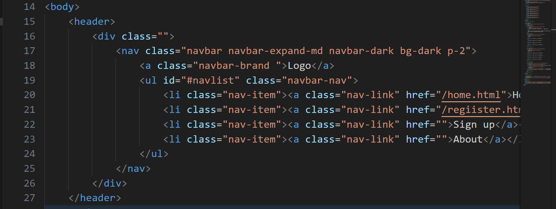

#### Main

* The second part of the body.
* Container class to control the alignment of its content.
* Card class can farther be divided to header, body and footer.
* 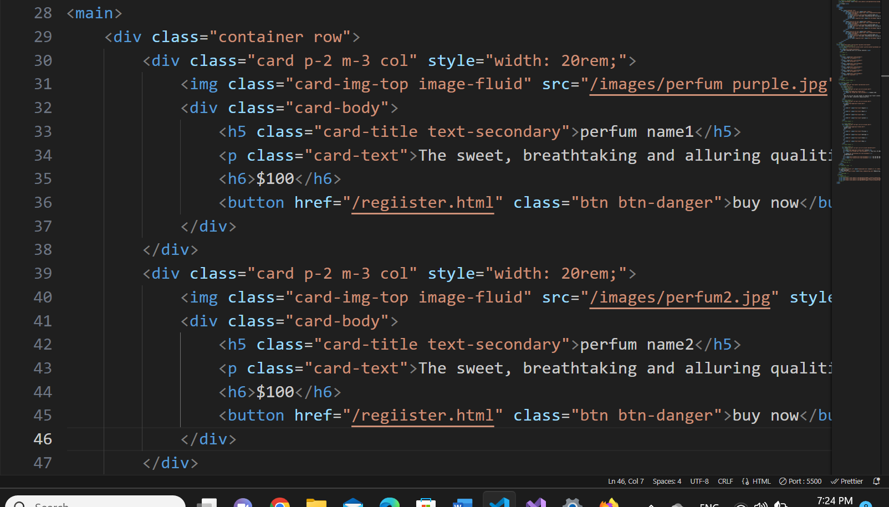

#### Footer

* The footer codes are from mdbootstrap website.
* Inside the footer there are two sections and at the end there is a copy right.
* The first section is line with social media icon which when the user press it will direct them to other page.
* The second section contains the body of the footer.
* 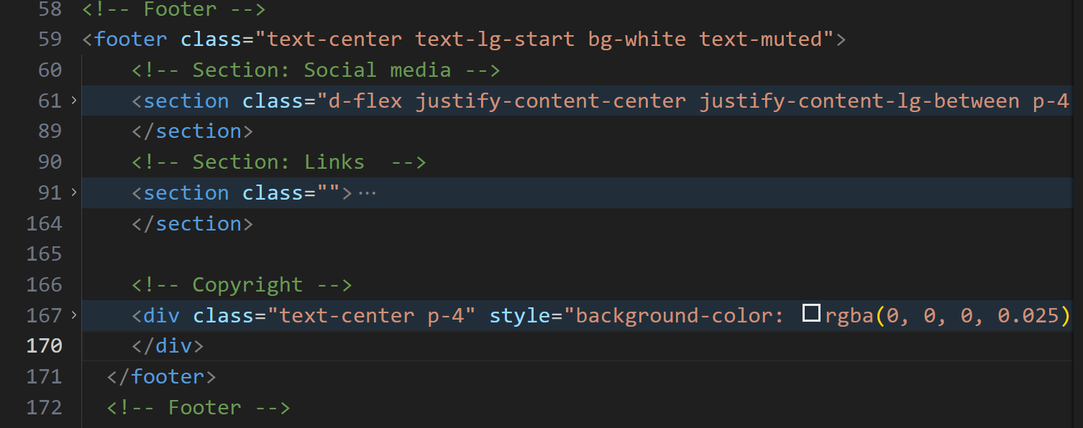

### Result

* A screenshot of a computer

  Description automatically generated
* A screenshot of a computer

  Description automatically generated

## register page

The header and the footer are the same as Home page. The different is in the main part:

### Codes:

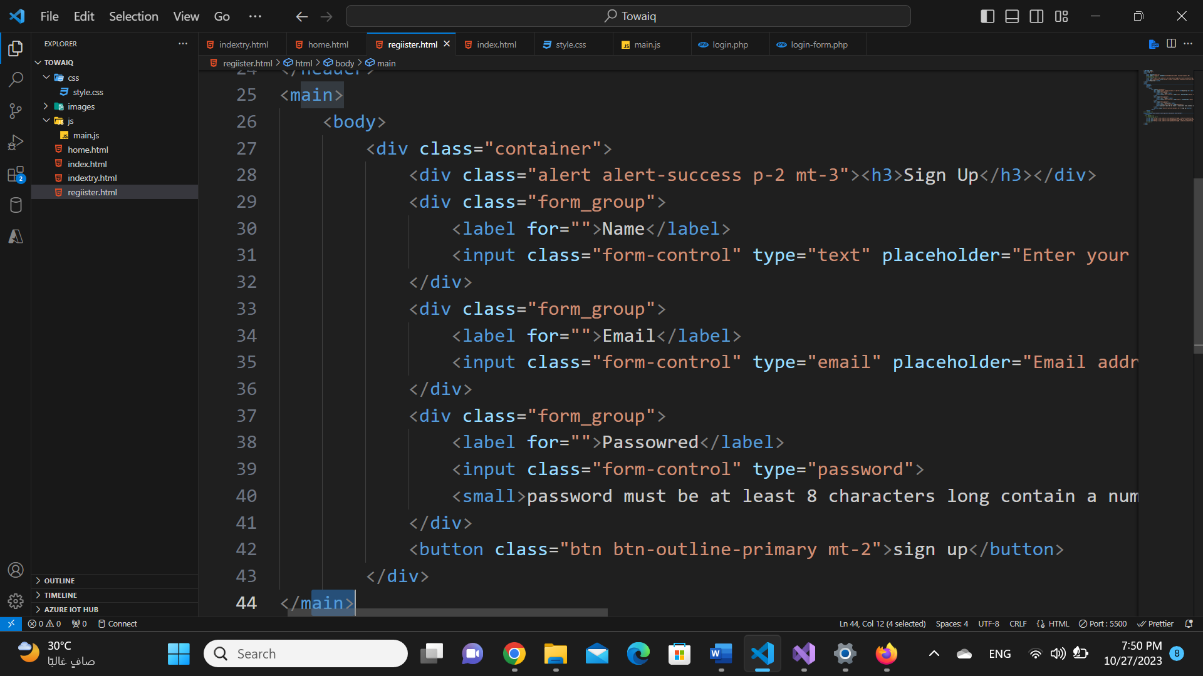

### Result:

* 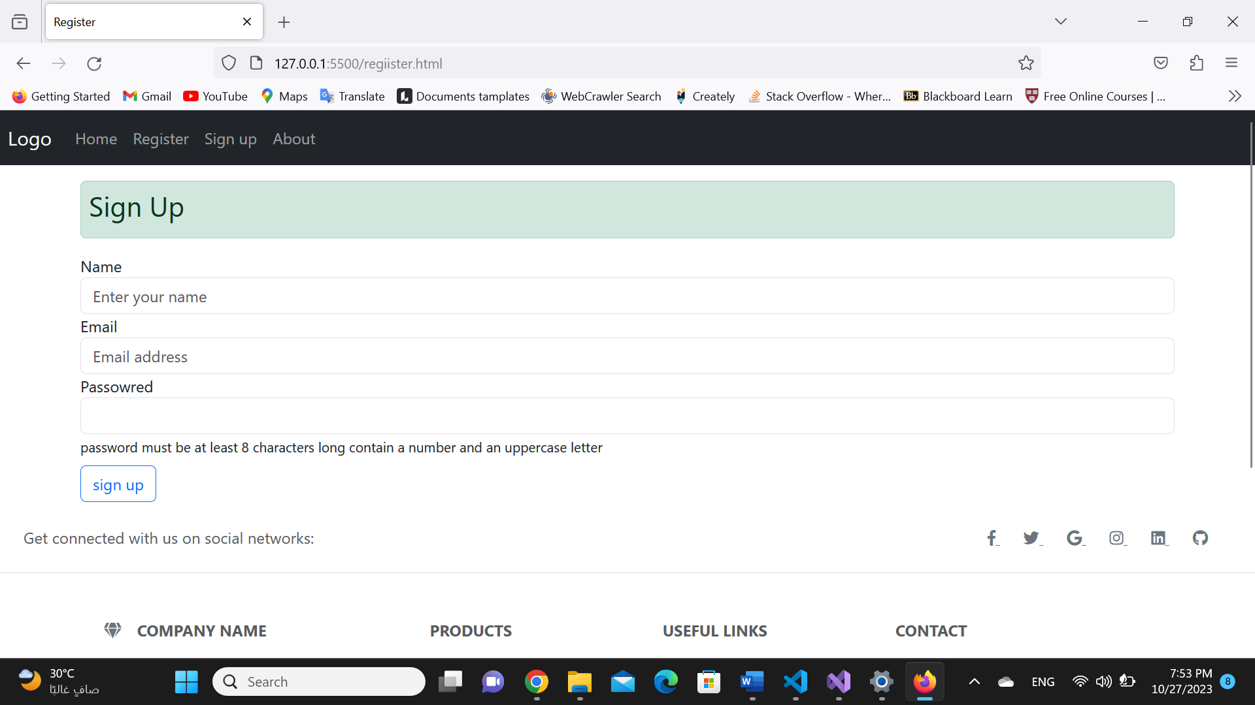

References:

1. Bootstrap
2. [mdbootstrap](https://mdbootstrap.com/docs/standard/navigation/footer/).
3. [Freepic](https://www.freepik.com/premium-psd/perfume-bottle-green-smoke_14058549.htm#page=1&query=undefined&from_query=undefined&position=1&from_view=detail_alsolike).